“Fuel level %” channel ?????
- Fuel level % is not present, just Fuel level itself measured in liters (name: Fuel_level), and remember it is measured in the collector, so if I understood well you start getting a significative information from it when fuel goes under a certain % of full tank condition.
In any case tomorrow, when Samuele is available, I’ll try to get a “Fuel level %” channel, and will add it to the Formulas (I’ll write you as soon it will be ready!)

Brk wear is zeroing when -????
- Brk wear is a topic we are facing more in deep these days, but it should never zero, the value you read is more the point at which a linear sensor is positioned instantly, and so, knowing extreme values of disk+pads stack, who reads can argue the state of wear.
But for sure this is a datum to be made more user-friendly, I’ll speak with Samu and update you with the possible outcomes and solutions (of course if you have any preference let me know )
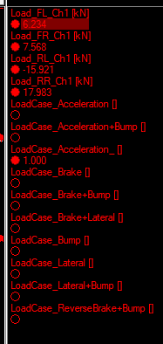
- This is a page asked from Mark the day before Monza Day1, where he could see if loads went above design limits imposed for suspension components mainly.
What you see under loads at pushrods are just true/false conditions coming from design spec sheet loadcases.
In particular:
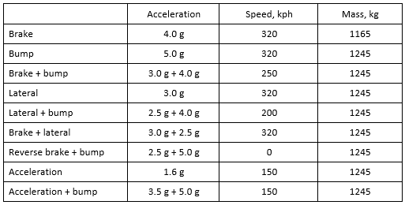

For me layout steeringwheel is not necessary knowing the new telemetry page(s)
- I agree with you honestly, the page steering wheel was more like a memo for me to provide a page where to see the ateering status, started from Mr. Bruno request of having a page showing what happened during laps to steering wheel settings.
But from my point of view is totally indifferent, if you think that having the information we put in telemetry pages is enough, I remove it (making also shorter the list of channels to go across to find things)
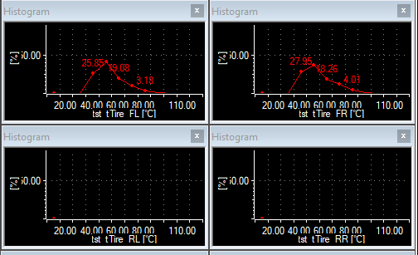
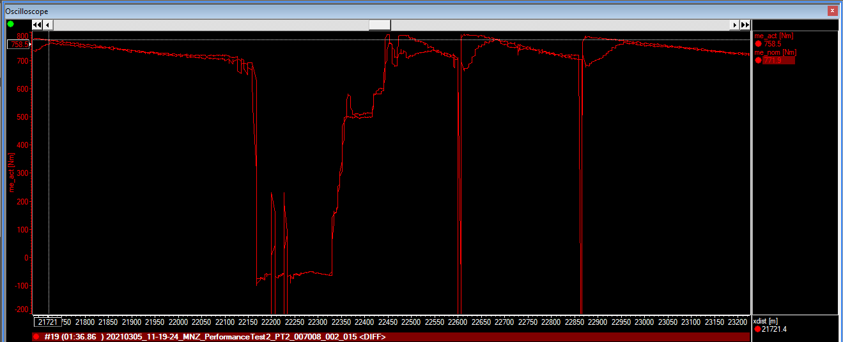
- This are histograms (with just the option of showing bar values) of the IR sensor under louver measuring surface temperature of the tires. I thought to put them in order to see which was the most recurrent temperature range over a lap/interval

- A preliminary and embryonal page to store data about TC (me_act, if I remember well is the actual torque cut by TC, while me_nom the nominal one it should cut depending on the position across maps the car is occupying in the particular instant), but it is more a postpro page for sure, I have to discuss with Stefan what he could want to see in a possible TC page.

